**PRACTICAL 7**

**a) Install Selenium IDE and explain the steps**

STEP1:

* Go to the browser “Mozilla Firefox”.
* Click on the options icon in right top corner and select Add ons and themes in the drop down list.
* Search for “Selenium IDE” and add that as an extension to the browser.
* Selenium IDE’S launch icon will be seen in the top right corner.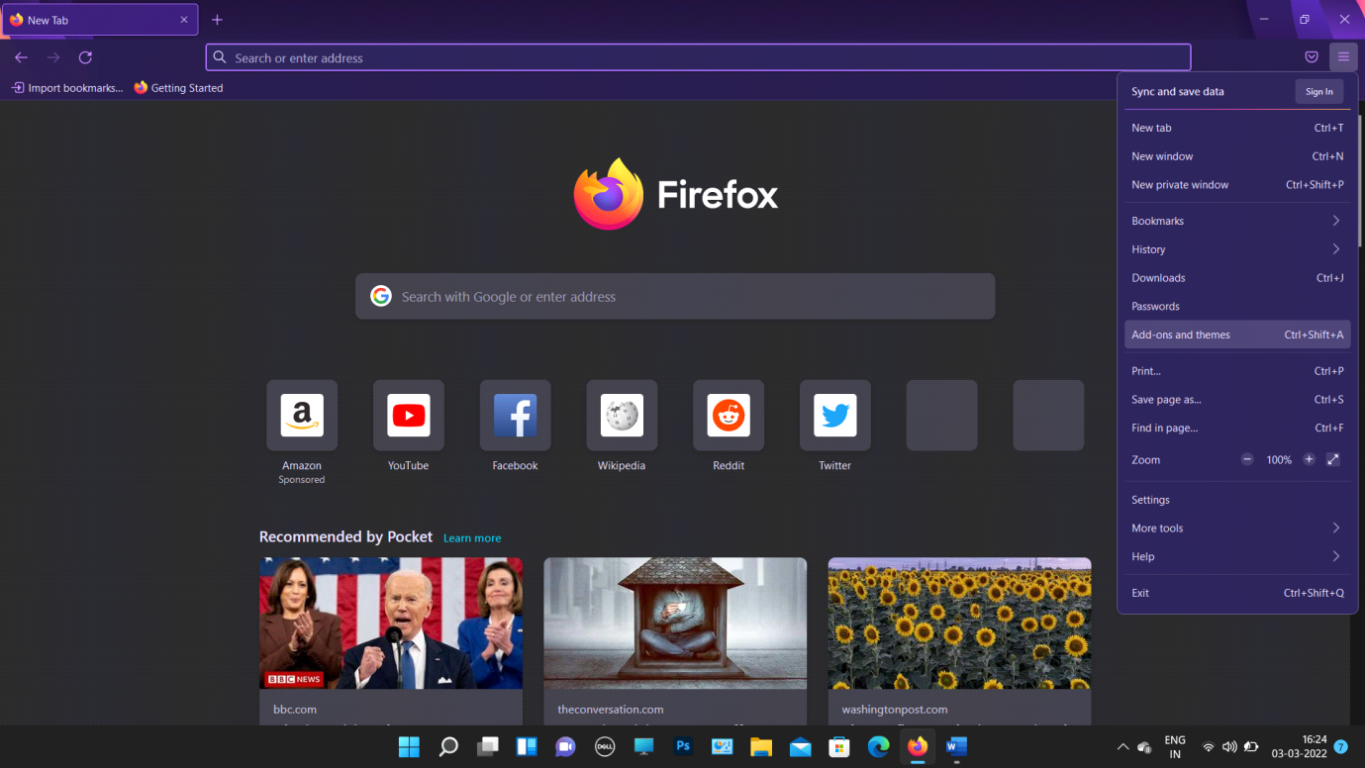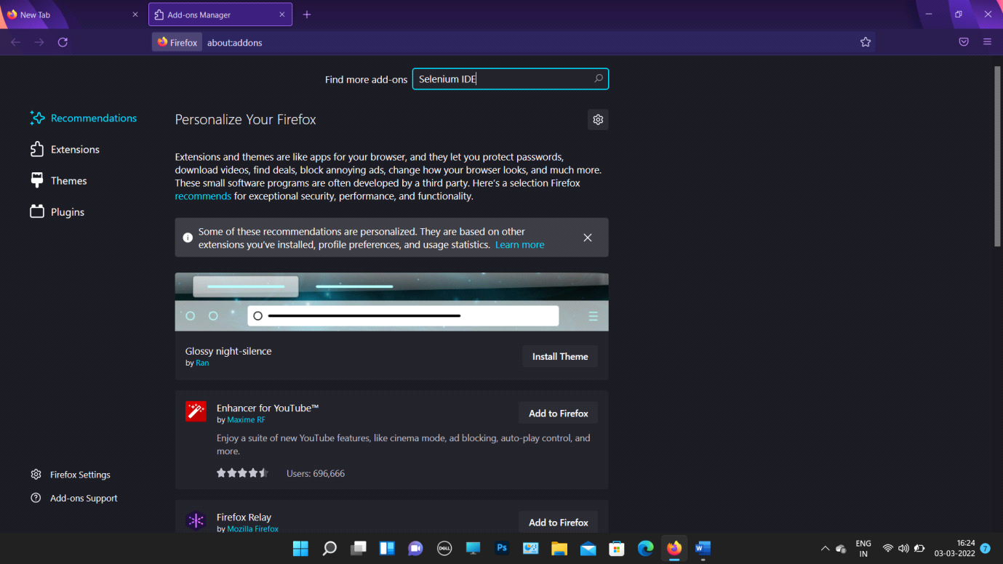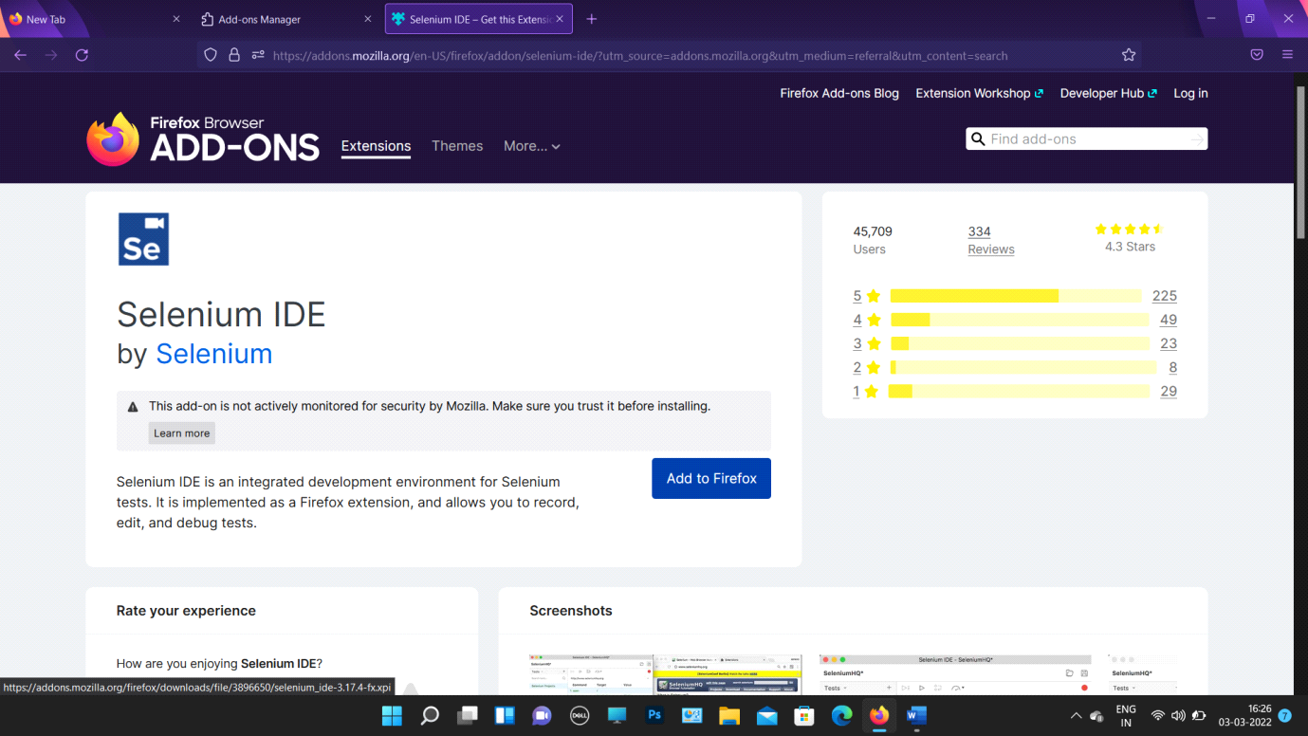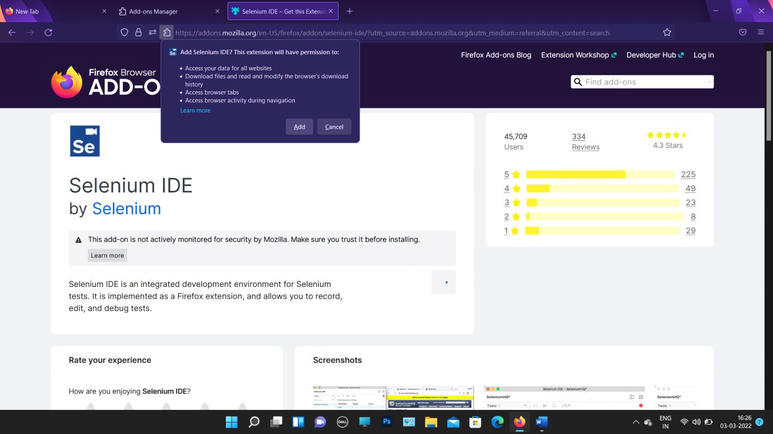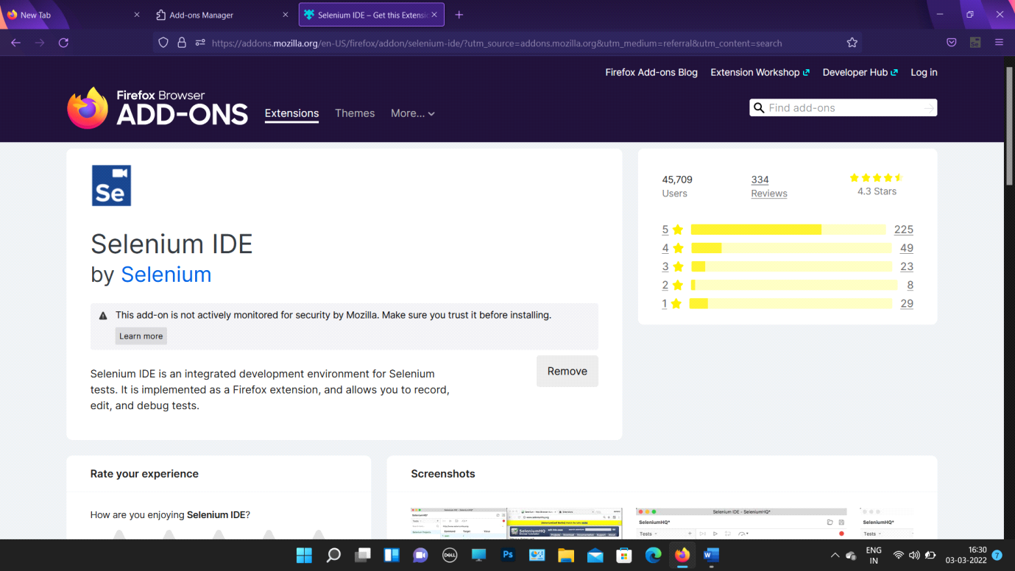

**B ) Create a recorded test Script using Selenium IDE**

STEP2:

* Launch Firefox
* Launch Selenium IDE by clicking on its icon in top right corner.
* Select “Record a new test in new project” and provide a name to the test case.

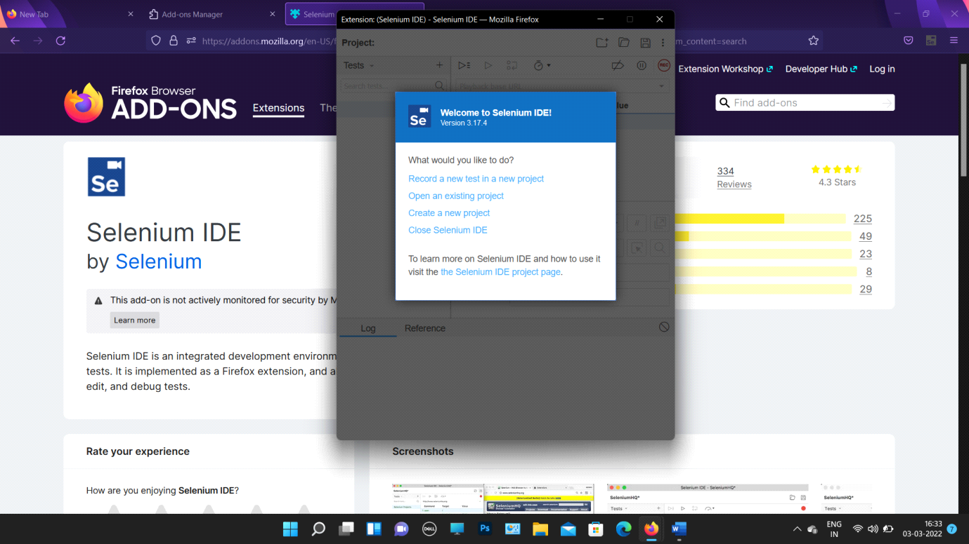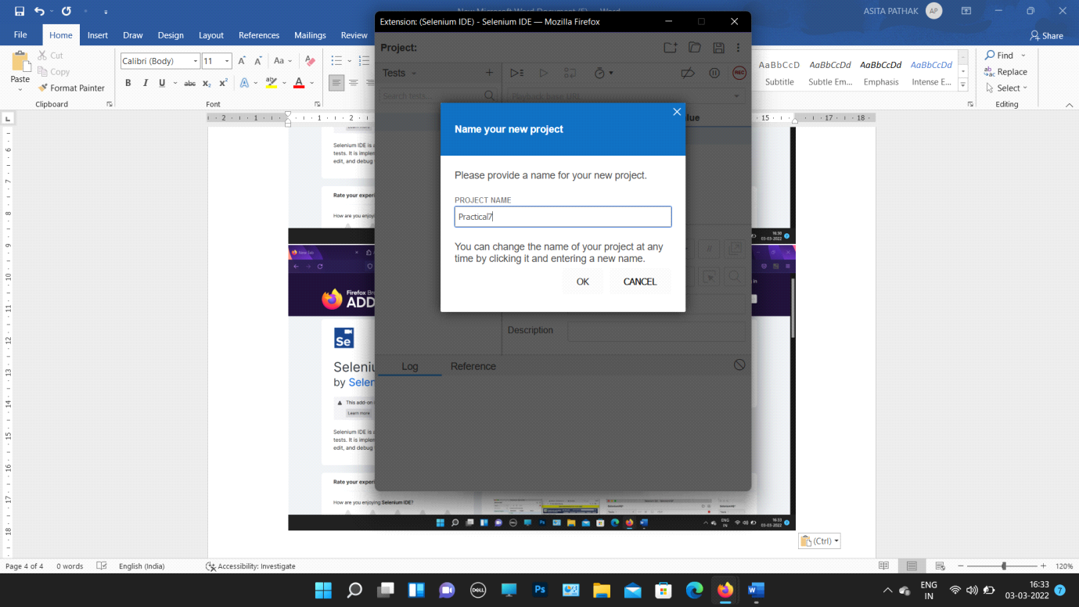

STEP 3 :

* Search for “new tour demo” in a new tab.
* Go on the marked link in the below picture.
* Copy the URL of the site and paste in base URL tab opened in the end of STEP2.

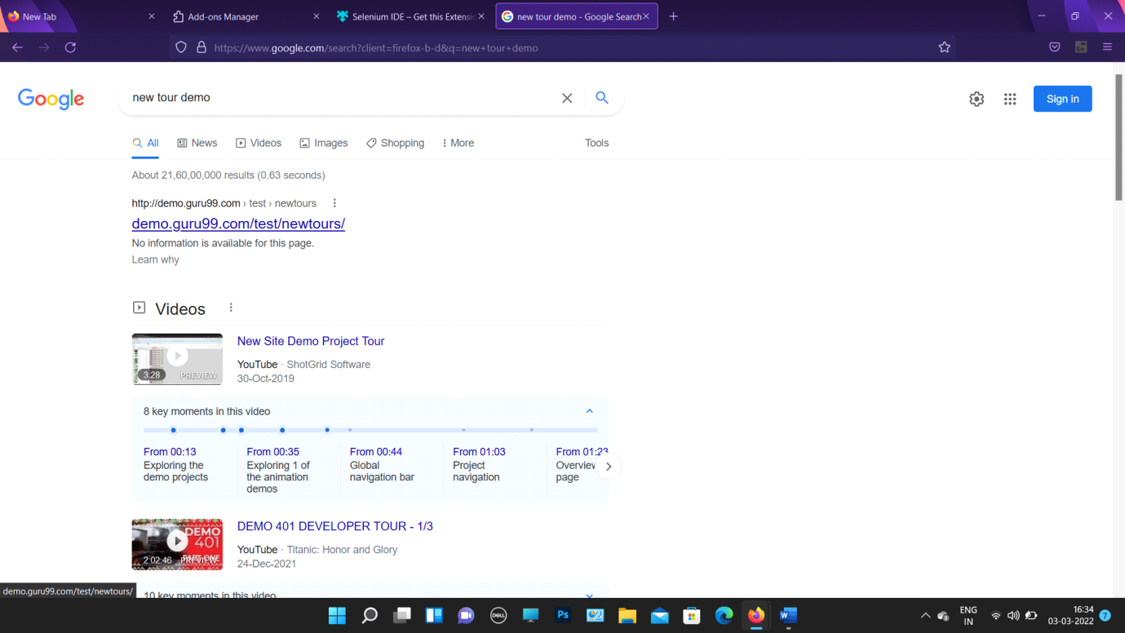

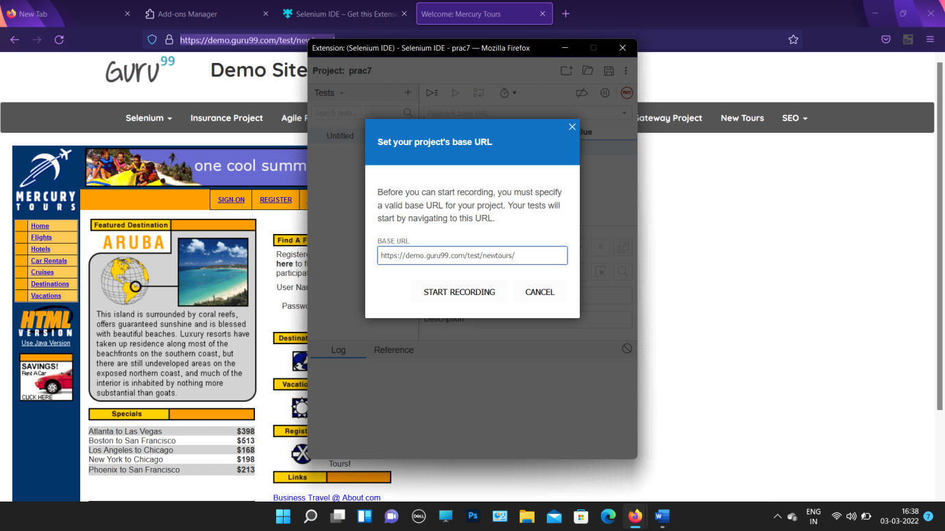

STEP 4 :

* The site of the copied URL will be opened.
* Feed the username-invalidUN

Password-invalidPW

* A page showing “Login Succefully” will be shown.

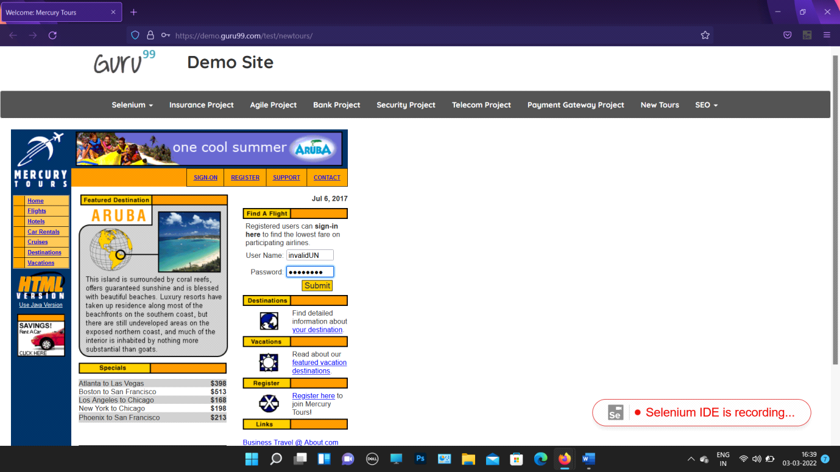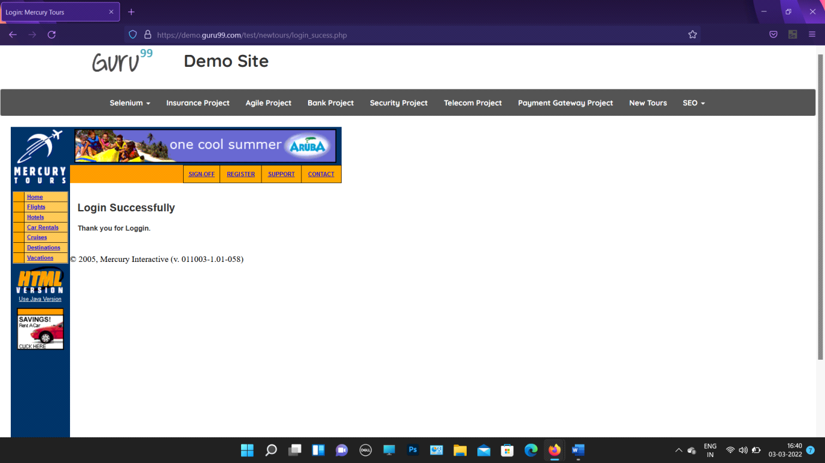

STEP 5 :

* Signoff from the site and save the test case with the name “prac7”.
* Stop the recording from the extension window of Selenium IDE.
* Run the current test case.

